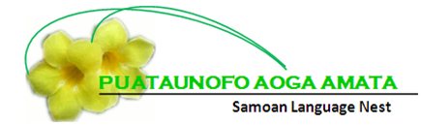

Centre Philosophy

We are a Samoan language based Early Childhood Education Centre affiliated to the Samoan Presbyterian Church in Ranui, West Auckland.

We believe in the importance of Christian values, Gagana Samoa and Aganuu (Samoan language and culture).

We welcome and value people from all diverse cultures and backgrounds.

Our curriculum is based on Te Whariki which is the National Early Childhood Curriculum.

We acknowledge and respect Te Tiriti O Waitangi and Maori as Tangata Whenua. Empowering relationships through aroha (love), whakawhirinaki (trust), manaakitanga, (Care, Integrity and Respect) and Whanaungatanga (Sense of Family).

As warm caring educators we believe in providing a collaborative learning environment which models strategies to support children to be confident and thriving. We welcome parents to share their aspirations for their children through stories and conversations, where their Culture and language will be strengthened.

We aim to provide a safe, caring and loving environment where our children are nurtured spiritually to grow and learn alongside each other in the wider community.

We believe in providing quality care and education so our children will leave our centre with a love for learning that will continue throughout their lives.

Alagaupu:

Faataoto 22:6
Aoao le tama e tusa ma ona ala, a oo ina matua, e le toe te’a ese ai

Proverbs 22:6
Train up a child in the way they should go, and when the child is old,
they will not depart from it.

Whakatauki

Poipoia te kakano
Kia puawai

Nurture the seed and it will blossom

